Automated Stapler for Motor Manufacturing

Preliminary Proposal

23 Summer – P4
Stetson Thola
Shaojie Wang
James Warner
Xuyang Chen
Michael Weaver
2023
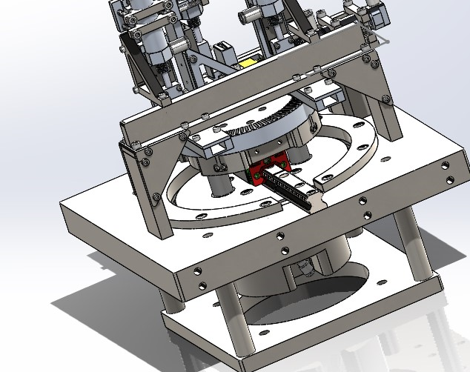

Project Sponsor: David Calley
Instructor: Armin Eilaghi

DISCLAIMER
This report was prepared by students as part of a university course requirement. While considerable effort has been put into the project, it is not the work of licensed engineers and has not undergone the extensive verification that is common in the profession. The information, data, conclusions, and content of this report should not be relied on or utilized without thorough, independent testing and verification. University faculty members may have been associated with this project as advisors, sponsors, or course instructors, but as such they are not responsible for the accuracy of results or conclusions.

EXECUTIVE SUMMARY
Elemental Motors is a locally owned and operated business in Flagstaff, Arizona and they have developed electric motors that greatly outperform their competitors. Their motors can achieve 10 times more torque per unit volume than any other electric motor on the current market. Since Elemental Motors is able to achieve this incredible torque within such a small motor their current demand has rapidly increased. This rise in demand is where the pneumatic manufacturing stapler team comes in to help increase their production of motors. Teaming with Elemental Motors, the team and our client David Calley have decided on a fully automated machine that will speed up the most time-consuming step in the manufacturing process.
These electric motors have three magnet rings that make up a single motor, and each one of the rings requires 160 total small pieces to be placed correctly. There are 80 concentrators and 80 magnets of similar size and shape, with half of the magnets having an opposite polarity. It currently takes roughly 30 minutes to assemble one magnet ring by hand. With the design of a pneumatic manufacturing stapler, the team will accomplish this ring construction in under three minutes, saving a large amount of time. This pneumatic stapler will consist of three major subsystems throughout the entire system. The first subsystem being the concentrator stapler with two similar pneumatic cylinders, one being in the vertical orientation and one being in the horizontal orientation, this system will place all 80 concentrations. The next system is the magnet stapler, consisting of two mirrors staplers, one for each of the magnet polarities. This system will be placing the magnets after all of the concentrators are in place. Finally, the last major system is the turn table driven by a motor from Elemental Motors. This turn table is responsible for correctly aligning each stapler so the components can be placed in the right spots. We will achieve this precision but using an encoder that gives the motor 100,000 steps per 1 revolution.
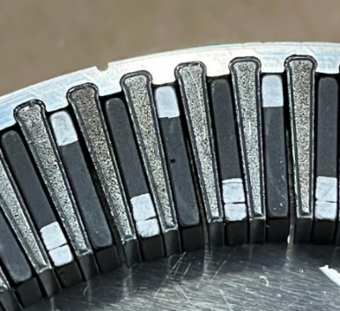
Figure 1: Concentrators and Magnets Correctly Placed
Eventually the team decided on a design that included all three of these subsystems and was able to function as efficiently as possible. Then a CAD model was generated to determine tolerances and clearances along with the practicality of making the machine. Once the CAD was finalized the team presented the design to our client David, the client would have liked to use electric actuators over pneumatic because of their programmability and feedback. Due to the short timeline given by the client the decision was made to use the pneumatic actuators for faster construction and functionality testing. After the client approved the design David gave the go ahead to begin machining and building the pneumatic stapler
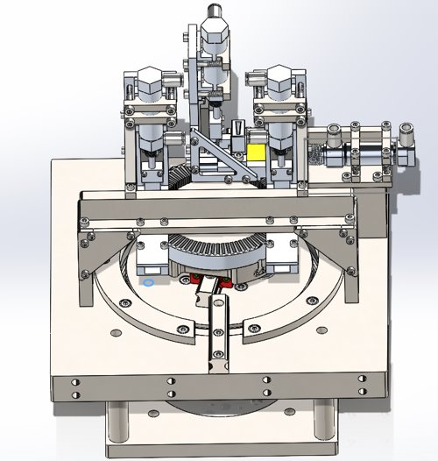
Figure 2: Stapler with Three Subsystems

TABLE OF CONTENTS
[Use Word to delete the following Table of Contents and insert a new TOC. Include front matter (except for the cover page), body of the report, and all appendices. The Table should include three levels of headings, e.g., down to 2.3.1, as illustrated below. Front matter should be in Roman numerials.]
DISCLAIMER 1
EXECUTIVE SUMMARY 2
TABLE OF CONTENTS 4
1 BACKGROUND 1
1.1 Introduction 1
1.2 Project Description 1
2 REQUIREMENTS 2
2.1 Customer Requirements (CRs) 2
2.2 Engineering Requirements (ERs) 2
2.3 Functional Decomposition 3
2.3.1 Black Box Model 3
2.3.2 Functional Model/Work-Process Diagram/Hierarchical Task Analysis 4
2.4 House of Quality (HoQ) 4
2.5 Standards, Codes, and Regulations 5
3 Testing Procedures (TPs) 7
3.1 Vibration Testing 7
3.1.1 Objective 7
3.1.2 Resources Required 7
3.1.3 Schedule 8
3.2 Drop Testing 8
3.2.1 Objective 8
3.2.2 Resources Required 8
3.2.3 Schedule 8
3.3 Component Loosening Test 8
3.3.1 Objective 8
3.3.2 Resources Required 8
3.3.3 Schedule 9
3.4 Static Stress Testing 9
3.4.1 Objective 9
3.4.2 Resources Required 9
3.4.3 Schedule 9
3.5 Fatigue Testing 9
3.5.1 Objective 9
3.5.2 Resources Required 10
3.5.3 Schedule 10
3.6 Speed Testing – Stapler 10
3.6.1 Objective 10
3.6.2 Resources Required 10
3.6.3 Schedule 10
3.7 Speed Testing – Rotating Base 10
3.7.1 Objective 11
3.7.2 Resources Required 11
3.7.3 Schedule 11
3.8 Efficiency Testing 11
3.8.1 Objective 11
3.8.2 Resources Required 11
3.8.3 Schedule 11
4 Risk Analysis and Mitigation 11
4.1 Critical Failures 13
4.1.1 Potential Critical Failure 1: Component Misalignment 13
4.1.2 Potential Critical Failure 2: Accumulation of Magnetic Dust in Magnet Ring 13
4.1.3 Potential Critical Failure 3: Excess Vibration in Base 13
4.1.4 Potential Critical Failure 4: Accumulation of Debris on Rotation Mechanism 13
4.1.5 Potential Critical Failure 5: Guide Channel Wear 13
4.1.6 Potential Critical Failure 6: Mistimed Motor Activation 13
4.1.7 Potential Critical Failure 7: Excessive Vibration in Concentrator Stapler 14
4.1.8 Potential Critical Failure 8: Excessive Friction on Slide Rails 14
4.1.9 Potential Critical Failure 9: Chipping or Cracking 14
4.1.10 Potential Critical Failure 10: Buildup of Debris in Magnet Guide Channel 14
4.2 Risks and Trade-offs Analysis 14
5 Design Selected – First Semester 16
5.1 Design Description 16
5.1.1 The Concentrator Stapler and The Magnet Stapler 16
5.1.2 The Rotating Base 17
5.1.3 The Direct Drive Motor System and The Pneumatic Actuator 17
5.1.4 PLC System 18
5.1.5 Design changes 18
5.1.6 Engineering Calculations 19
5.1.7 Learning and Reflection from prototype 19
5.2 Implementation Plan 20
5.2.1 Preparation of the implementation plan 20
5.2.2 Resources required to implement the plan 22
5.2.3 Second Semester Schedule 25
6 Conclusion 25
7 Appendices 26
7.1 Appendix A: FMEA 26
7.2 Appendix B: Bill of Materials 29

BACKGROUND

Introduction
Our project was to design and build a machine for manufacturing electric motor magnet rings. This machine is a precision pneumatic stapler that will automate one step of motor manufacturing. The goal of this project is to replace the manual process of placing all 160 pieces by hand with an automated process. Through this project, our project sponsors wanted to significantly increase the efficiency of their workshop's motor production, increase profits through higher supply and open up new markets. The importance of this project is that it will improve the time required to assemble each one of the magnet rings that contains the 80 concentrators and 80 magnets from the traditional 1- 2 hours by hand to 3 minutes automated. This project will be able to solve the issue of meeting motor demands by decreasing manufacturing time and increasing motor production.

Project Description
Following is the original project description provided by the sponsor：
The primary objective of this project is to develop a system that is fully automated and significantly reduces the time required to build electric motors. As demand increases the need for this highly efficient and speedy system is a must for Elemental Motors. The development of this stapling system significantly impacts Elemental Motors and their ability to meet large supply demands.

REQUIREMENTS
After meeting with the client David Calley, team 4 has come up with eight different needs/ requirements that must be present in the pneumatic stapler. As mentioned by David these eight requirements are a must for the stapler to be a functioning part of Elemental Motors’ manufacturing machine. These requirements are based on several components and are present in similar systems that make up the motor manufacturing machine. Found below are the customer requirements that were given by the client for the pneumatic stapler. While configuring the client requirements the team also decided on seven engineering requirements listed below that will be used as a guide for the development of the stapler.

Customer Requirements (CRs)
The customer requirements are based entirely on what the client needs within the system. They are used as the outline for building the final project design. Using the customer requirements, the team stays within the parameters while designing the stapler. Each one of the requirements is given a weight or ranking to determine the importance of that particular requirement. These weights are from 1 to 5 with 1 being the lowest priority and 5 being the highest priority. The importance of these weights keeps the team on track and focused on the most important topics. Listed below are the customer requirements with the weights and description present for a better understanding.
- High Speed (4): This stapler is responsible for placing 160 total pieces into a magnet ring that has a diameter of 115 mm. While the stapler is functioning, it needs to place all 160 pieces within a total time of 3 minutes. This time of 3 minutes is based on similar systems that complete their tasks in the same amount of time
- High Efficiency (5): The efficiency of the stapler comes down to how well its functions without experiencing an error in the operation. As stated by the client, this stapler needs to function 100% with no errors experienced.
- Functioning prototype (5): Another critical component of the stapler development is producing a functioning prototype. For the prototyping of the stapler, it will need to be fully modeled on CAD by the first week of July. Having it modeled on CAD the prototype can be either 3D printed or machined to test its functionality during the month of July and August.
- Size (1): Based on its weight and the client needs, the size constraints of () for the stapler is not critically important. It is helpful to stay withing this size constraints but not absolutely necessary for a functioning stapler.
- Cost Effective (3): To design a feasible stapler for Elemental Motors it will need to be relatively cost effective. The total cost to develop this stapler needs to stay within the allowed budget while providing a functioning and reliable machine.
- Fully Automated (4): Apart from loading the machine with the 160 total components it needs to function fully automated. After being loaded the stapler needs to place the pieces without any human interaction until the magnet ring is fully assembled.
- Long-Lasting (3): The stapler needs to function for months on end without being replaced, taken apart, or maintained. It needs to contain high quality machined components and parts to avoid the stapler failing.
- High Torque (2): To support the torques applied on the turn table the motor needs to supply a high torque. The high torque needs to be able to lock the turn table into position and keep it from moving when magnets are placed.

Engineering Requirements (ERs)
From the client meetings the team was able to set up the customer requirements. And then the team used those customers' requirements to decide on the engineering requirements. The engineering requirements are used to showcase how the client's needs will be met. Using both a measurable scale and tolerances the team will be able to satisfy the client. Setting these ER’s, the team can quickly reference what is needed while being able to easily communicate the ERs to David. Listed below are each one of the engineering requirements along with their targets, tolerances and justifications.
- Decrease cost: The direct drive motor is produced in-house, costing the company roughly $150 to produce compared to around $300 for high-quality gear boxes. For all designs, 12” of 1” stainless steel round is $379.65 compared to $8.09 for aluminum, so all parts will be made of aluminum outside of those susceptible to fatigue. Ideally decreasing the cost by about $500 with a tolerance of $50.
- Improve Efficiency: Fewer moving parts leads to increased accuracy and makes the target of 0 misplaced parts much more possible. While using a direct drive system 100,000 steps per revolution can be achieved by switching from a 17-to-21-bit encoder. This resolution will provide precise positioning allowing for 0 errors. Increasing the resolution from 40,000:1 to 100,000:1 with zero tolerance.
- Improve Quality: Fewer moving parts leads to less fatigue wear, regardless of design. Expected stresses on our design maxes out well below 130 MPa and should allow us far greater than cycles of operation for even the aluminum elements. Expected life cycles of with a tolerance of.
- Stronger Motor Specs: The direct drive system gives us 50 Nm of torque, while most servo/ stepper motors are around 3-4 Nm without an expensive gear box. Switching to direct drive we can achieve more torque from the in-house G3 114 motor with a much high precision. Achieving a torque of 50 Nm with a tolerance of Nm.
- Improve Programmability: Similar to efficiency, fewer parts lead to fewer lines of code required to control the system. Additionally, the direct drive system enables the use of a 21-bit encoder, allowing for greater control compared to the 17-bit encoder used by the alternative drive systems. Using a 21-bit encoder with zero tolerance within the programming.
- Size Constraints: The build space is set by the client based on the total size of the motor manufacturing machine. Each subsystem was given a size constraint for all systems to fit. There are no height restrictions given if the system functions. Without a belt or gearing system, this design can easily fit in the space. Required size of with a tolerance of.
- Improve Machining: Currently the estimated machining time is calculated at 80 hours costing $1.50 per minute of machining. With the reduction of parts and part complexity the machining price will decrease from $1.50 to roughly $1.00, along with decreasing the total machining time. The desired machine costs $1.00 with a $0.25 tolerance.

Functional Decomposition

Black Box Model
A black box model is a type of machine learning or statistical model that makes predictions or decisions based on input data, but its internal workings are not transparent or easily interpretable by humans. In other words, it operates like a "black box," where we can observe the input and output, but the internal mechanisms and decision-making processes remain hidden from view.
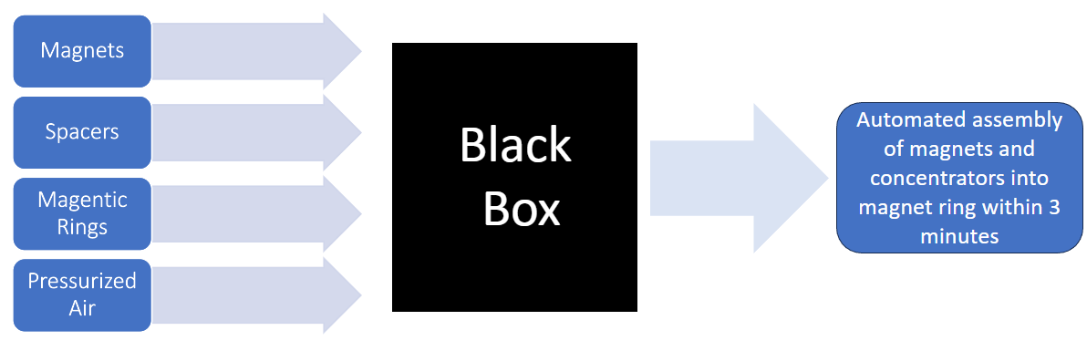
Figure 3: Black Box Model

Functional Model/Work-Process Diagram/Hierarchical Task Analysis
The model helped us to better segment the various subsystems, allowing us to allocate our time to design and test different systems in an organized manner, improving overall productivity. 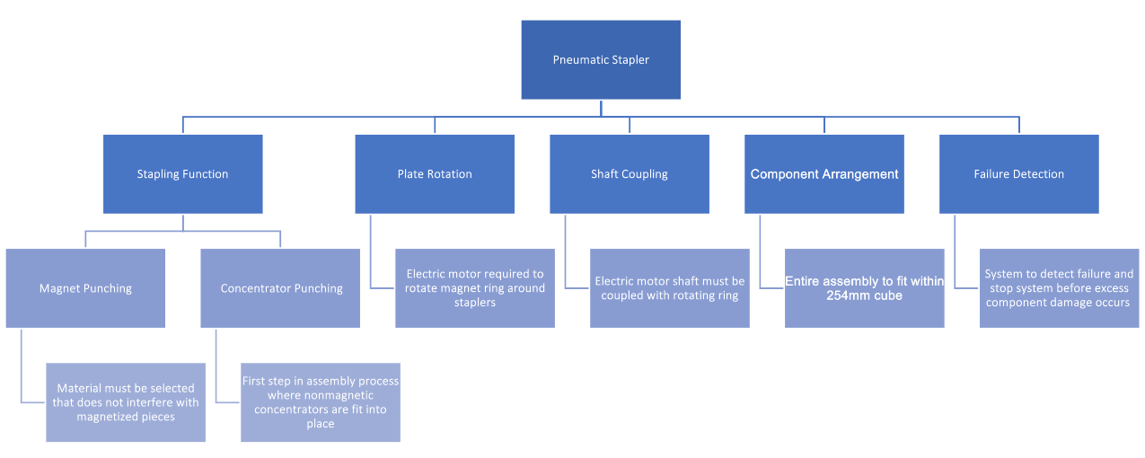
Figure 4:Functional Decomposition

House of Quality (HoQ)
The House of Quality, which is also known as the QFD has been a critical aspect of the stapler design. Setting up this QFD allows the team to build a relationship between both the engineering requirements and the customer needs. This relationship is important when deciding what area to focus on during the design. Along with the design process the QFD is a great tool that the team can use to present the design process with critical information to the client. From there the client can approve the priorities are correct along with helping the team brainstorm additional ideas to achieve each requirement. As the team moves forward with the development of the stapler the QFD plays an important role in keeping the team on track and focused. Since it outlines the needs of both the client and the team it is useful to references when making sure that each task is done to the specifications of the client. These specifications need to be met in order for the client to be pleased with the process and eventually the overall design on the staple.
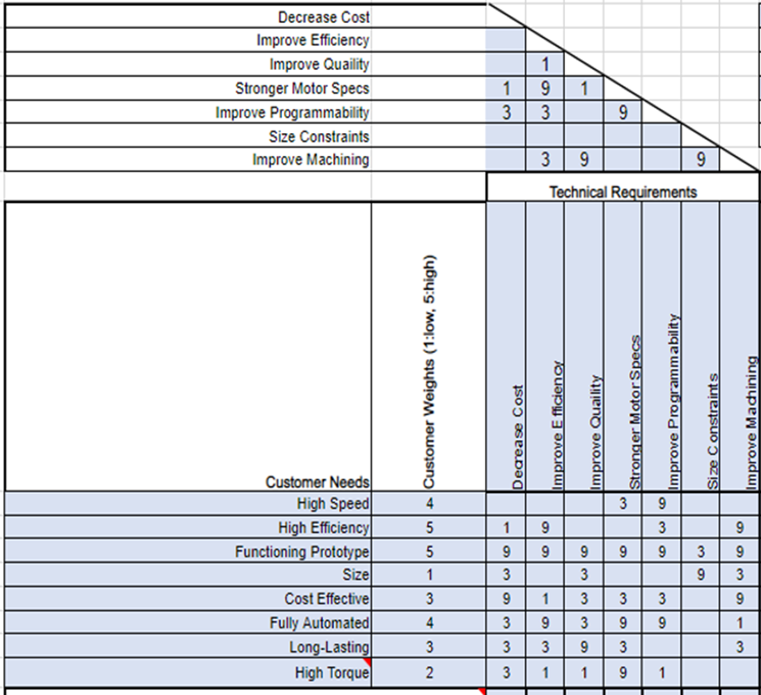
Figure 5: QFD
The full QFD can be referenced in appendix A for a better understanding of the team's top priorities. This is a sample QFD that shows the direct relationship between customer and engineering requirements. Found in the figure above a rating from 1 to 9 is given based on the importance of the relationship with 9 being the highest and 1 being the lowest. Within the relationship section all the blank boxes indicate that there is no direct relationship between the two different requirements. These relationships are then used to build a rating system that is used to determine the importance of each requirement. From the importance rating the team will focus its attention on the most important client needs before addressing any secondary or low priority requirements.
Detailed information on the testing process can be found in Part 3.

Standards, Codes, and Regulations
Standards and codes come from many organizations and societies. Examples of those that most directly apply to Mechanical Engineering projects include (but are not limited to):
- Aluminum Association (AA)
- American Gear Manufacturers Association (AGMA)
- American Iron and Steel Institute (AISI)
- American National Standards Institute (ANSI)
- American Society of Mechanical Engineering (ASME)
- American Society of Testing and Materials (ASTM)
- American Welding Society (AWS)
- American Bearing Manufacturers Association (ABMA)
- Industrial Fasteners Institute (IFI)
- Institute of Electrical and Electronics Engineers (IEEE)
- International Standards Organization (ISO)
- National Institute for Standards and Technology (NIST)
- Society of Automotive Engineers (SAE)

Table 1: Standards of Practice as Applied to this Project
Standard Number or Code | Title of Standard | How it applies to Project
ASME B30.1 | Safety Standard for Pneumatic Tools | Ensures safe design and operation of the pneumatic stapler.
ANSI B11.19 | Performance Criteria for Safeguarding | Provides guidelines for safety measures during stapler operation.
ASTM A666 | Standard Specification for Annealed or Cold-Worked Austenitic Stainless-Steel Sheet, Strip, Plate, and Flat Bar | Specifies suitable materials for specific components in the stapler.
ISO 3834 | Quality Requirements for Fusion Welding of Metallic Materials | Ensures welding processes meet quality standards in stapler manufacturing.

Testing Procedures (TPs)
The following section covers the main tests that will be used to verify that the team’s project meets all engineering and customer requirements. Several requirements do not lend themselves to testing procedures or can be verified using other tools. Examples include the device’s size being constrained to a 254-millimeter cube or the need to keep the total cost of the project under $10,000 dollars. These can be verified in the final CAD package and the budget, respectively. For this reason, the following test procedures were selected based on both the customer and engineering requirements as well as the Failure Mode and Effect Analysis. Taking both of these into consideration will allow the team to thoroughly verify that all requirements are met while also mitigating possible sources of failure. Simulations are also included here because they serve as reliable ways of testing things that would be costly or too difficult to physically test. Examples include vibration, fatigue, and drop testing.

Vibration Testing
This test will be used to determine the resonant frequencies of the device to ensure that it is not exposed to these frequencies and prevent failure. This test will consist of two parts, one simulation and one physical experiment.

Objective
The first portion of this test will be to use SOLIDWORKS simulation to determine the devices natural frequencies. This process will start by selecting fixtures that will not be subjected to vibration, meshing the assembly, and running the simulation to determine the first five lowest natural frequencies. The first five should cover the range of frequencies that could reasonably affect the device. This process may have to be done multiple times with various simplifications and reasonable fixture choices to give the team the team the best understanding of the device’s actual resonant frequencies.
The next method of testing resonant frequencies was suggested by our client David Calley and offers a simplified way to determine some of the device’s natural frequencies. This method involved striking the device and listening to the sound that gets produced. This can serve to verify that the simulation is accurate and aligns with the physical prototype. In addition to this the frequencies emitted from different devices in the Elemental Machine Shop can be tested in the same manner to determine where the team’s device can be placed.

While resonance is not very likely, it is still something worth testing for to prevent the large-scale failure that could occur if it did occur. The test results help ensure the device is placed in a safe environment and not exposed to dangerous frequencies from other devices involved in the manufacturing process. This becomes more relevant as Elemental Motors scales up production and continues to automate manufacturing.

Resources Required
Currently all physical testing is set to take place in the Elemental Motors machine shop. The first method of testing resonant frequencies can be done using SOLIDWORKS Simulation Premium. The second requires the use of a microphone and audio processing software. Both of these can be found online using the progressive web app Microphone Sound Analyzer found at www.compadre.org and using the microphone built into a laptop.

Schedule
The first portion of this test is set to be completed during the first semester by August 4th. This only requires a completed CAD model of the device. The second portion of the test is set to be completed during the first two weeks of the second semester and requires the use of a completed prototype.

Drop Testing
A drop test will be used to test that device is durable and robust, fulfilling the design requirement of long-lasting. This will be carried out using SOLIDWORKS simulation due to the high cost and time associated with damaging the components of our prototype

Objective
This test will be carried out in SOLIDWORKS and will include several variations meant to realistically simulate the ways that the device can drop. The device will be dropped from various heights and at various angles ranging from 0 to 90 degrees relative to its normal position. This will be done to determine if the device can withstand drops and better understand the precautions that need to be taken while handling and moving the device.

Resources Required
This test requires no additional resources besides SOLIDWORKS and the completed CAD assembly.

Schedule
This test will be conducted during the first two weeks of the second semester. It should be able to be completed within a couple hours because everything is simulated, and no special equipment is required.

Component Loosening Test
This test will be carried out to determine how quickly device operation contributes to the loosening of components like nuts, bolts, etc. This is relevant because there are multiple vibrating components that will gradually result in this loosening process. Examples include the pneumatic piston and the direct drive motor quickly rotating the base plate in short steps. This test will also fulfill the design requirement of long-lasting, because part of this customer requirement includes that the device will require little maintenance. This test will help determine the maximum intervals that the device can go without maintenance.

Objective
The first step of this test will be to specify the torque specification that will be needed for each of the device’s nuts and bolts. Next the full prototype will be assembled to fit these standards. After this, the device will be used to complete a specified number of magnet ring assemblies, and the torque on each hardware component can be tested to see if it was made loose by the operation of the device. This test will be iterated multiple times, varying the amount of magnet ring assemblies that gets produced. Increments of 2, 5, 10, 20, 50, and 100 assemblies will be tested for.

Resources Required
This test will take place at the Elemental Motors machine shop and require the use of a precise torque wrench and screwdriver. The team intends to purchase a precise electronic torque screwdriver that is able to test torque in increments of 0.1 in-lbs. Excel will be used to monitor these tests and determine the rate at which components loosen.

Schedule
This test requires a large amount of time in addition to a functioning prototype. The benefit here is that the device will be able to be tested while it is in operation and being used by our client. Taking an average of 3 minutes per completed assembly, the test will require approximately 9.5 hours to complete. This time estimate is of course subject to change because of possible errors in production or if it is found that the device becomes too loose before 100 assemblies are produced. For these reasons the test is scheduled to be completed by the 7th week of the second semester.

Static Stress Testing
Static stress on the device will be simulated using SOLIDWORKS to give the team the most realistic estimate of stress when hand calculations and physical testing are not applicable. The stress when the pneumatic piston is actuated and pushing down on the rotating base will be tested using the data gathered with the team’s stapler subsystem prototype. This was previously tested, and it was determined that when the pneumatic pistons are connected to the air supply without flow regulation, the downward force from the punching piece is roughly 44 lbf. This will serve as the input force during the static stress test.

Objective
This test is important because it allows the team to check how much the device will deflect just from operating the piston. This number serves as a minimum deflection because the tolerances and slight misalignment can increase this. Checking that deflection at the site of punching does not exceed the gap tolerance is critical and helps protect against our most probable mode of failure, component misalignment. This helps fulfill the customer and engineering requirements creating a functioning, efficient, and automated prototype. The test will run in SOLIDWORKS by using the vertical bars holding the assembly as fixtures and applying the determined force. This test is also being conducted because it is a prerequisite for completing a SOLIDWORKS fatigue analysis.

Resources Required
A load cell was used to determine the force from the pneumatic cylinder on the punching piece and surrounding components at Elemental Motors. This data will then be used with SOLIDWORKS simulation to complete the test and produce a plot of stress and deflection.

Schedule
This test is set to be completed by the end of the first semester as it is part of the team’s individual analysis assignment. It is important to get this done before the second semester because a stress test is needed to simulate fatigue.

Fatigue Testing
Fatigue testing will be necessary to determine if materials subject to high-stress are likely to deform or fail before the desired lifespan of 10E7 cycles. This test will confirm whether the choice to use aluminum for certain parts is a viable option and serve as a proof of concept. Simulation will be used to make this test possible. The main engineering requirement being verified here is the long-lasting requirement.

Objective
This test will run using SOLIDWORKS simulation. Starting with a complete static stress test on the overall assembly, the fatigue test can proceed. To provide the most realistic results, a zero-based loading type will be used to have the applied force oscillate between zero and the maximum force from the piston. From here the number of cycles can be inputted and the results will show the percentage of the component life that was used by the specified number of cycles. This will be useful by allowing us to see what components, if any, need to be replaced and how often this is needed.

Resources Required
This test can be completed virtually and does not require any resources besides the completed CAD model and information about the materials for each component.

Schedule
This test will also be completed by the end of this first semester as part of the team’s analysis assignments. Addressing possible failures caused by fatigue early one will allow the team’s material selection to be verified before a working prototype is machined.

Speed Testing – Stapler
Testing the functionality of the device at different speeds will be necessary to assure that the device meets the customer requirement of high-speed operation. It needs to be verified that the device can produce complete magnet-ring assemblies within 3 minutes. This works out to approximately 1 punching step every second. Verifying this requirement will be broken down into two testing procedures. The first tests the maximum speed that the staplers can reliably operate at. This will allow us to bound the maximum speed that the device can operate at and see where improvements to this customer requirement can be made. This test is also critical for developing the control system, especially if the control system is not basing its actions on feedback from the system.

Objective
This test will use a camera taking slow motion video to determine how long it takes for the pneumatic cylinder to fully extend and then retract at the selected air pressure. This test will be conducted on the subsystem prototype that the team has already built, which uses a switch to actuate the air supply. The team will record the process of switching the air supply on and see how long it takes for the arm to fully extend. In order to avoid human error when switching back and forth, it can be assumed that the amount of time it takes to extend the arm is equal to the amount of time it takes to retract the arm.

Resources Required
The first requirement of this test is the stapler subsystem prototype, which will be sufficient since it contains the same air supply, piston, and guiderails that will be used in the full assembly. For equipment, the current plan is to use an iPhone as the camera. In the slow-motion video mode, an iPhone is capable of taking 155 frames per second allowing the collection of data to be accurate within 6.5 milliseconds. Given that the punching and rotating step must be complete within roughly 1 second, this camera should be suitable for this test. If not, alternative cameras are available to rent from Northern Arizona University.

Schedule
This test will be completed within the three weeks of the second semester. This will give the team time to use the results in the control system and for the second speed test.

Speed Testing – Rotating Base
The next speed test will take place after the control system has been further develop. It will consist of testing various speeds for the rotating base. This test also helps fulfill the customer requirement of high-speed and is where the it can be confirmed to complete assemblies within 3 minutes.

Objective
This test will begin by commanding the motor to rotate in the increment needed for punching and testing how long this process takes. After this, the time needed for motor rotation will be added to the time needed to actuate the pneumatic cylinder and this sum will serve as the minimum time step needed for each punching action. Next, increments of 5 milliseconds will be added to this baseline time until a reliable amount of time is determined.

Resources Required
This test will use the same camera used in the last step. Next it will need a full prototype of the device and for the previous test to have been completed. It will also require a control system to be established that is able to control both the staplers and the motor

Schedule
Because multiple steps need to be completed prior to starting this test, it will be completed within the first 6 weeks of the second semester. This will give the team sufficient time to complete the prerequisite steps and enough time in the semester left to finish developing the control system and optimize the speed at which magnet ring assemblies can be completed.

Efficiency Testing
To meet the customer requirement of high efficiency over 90%, a metric that takes into account motor efficiency and device errors must be used.

Objective
This test will consider the motor parameters that are selected based on the previous two tests as well as errors in the production of magnetic rings. This can be determined using the contour plot provided by Elemental Motors which describes motor efficiency as a function of torque and motor speed. Then this value can be used as the baseline efficiency and modified based on the average number of errors that take place during production. Multiplying the baseline efficiency by the percentage of components that were stapled without error will then give an accurate measure of the energy efficiency of the device, counting errors as wasted energy.

Resources Required
This test does not require any special equipment other than a working prototype and taking large enough sample of stapling steps. The team has agreed that 3 magnet rings, or 480 stapling steps, is enough to take one efficiency value and will work to bring that number as close as possible to the motor’s efficiency, or all components stapled without error.

Schedule
This test will be conducted multiple times throughout the course of the second semester with the intention of gradually increasing the device’s energy efficiency. The first measure will be taken once the functioning prototype is complete.

Risk Analysis and Mitigation
In order to better understand the risks of the design that could lead to failure of the system, the team analyzed each subsystem of the potential design and predicted where failure could occur and what effect that failure could have on the efficacy of the project. Each potential failure was scored on a scale of ten for the severity of failure, the probability of failure, and the detectability of the failure. The product of these three scores constituted an overall risk priority score (RPN) that indicated how important the potential failure was to consider and mitigate. The resulting Failure Modes and Effects Analysis (FMEA), consisting of 40 possible failures (10 for each of the four subsystems), is presented in Appendix B, with the top 10 potential failures across the system as a whole presented in Table 2 below.
Table 2: Top 10 FMEA Concerns
Item / Function | Potential Failure Mode(s) | Potential Effect(s)  of Failure | Severity | Potential Cause(s)/ Mechanism(s) of Failure | Probability | Current Design Controls | Detectability | Risk Priority Number
Rotating Base | Component Misalignment | Failure to function, damage to components | 9 | Manufacturing errors or improper tolerancing | 7 | Determine acceptable tolerances and use CNC machine for precise machining | 3 | 189
Rotating Base | Accumulation of magnetic dust | Magnet ring assembly unable to be used in end product, device malfunction | 6 | Chipping of magnets or concentrators due to the impact of the punching piece | 5 | Ensure proper alignment and test what conditions generate magnetic dust | 6 | 180
Rotating Base | Excess Vibration | Misalignment of components, loosening of screws and other components | 6 | Vibration gradually loosening nuts, bolts, etc. | 8 | Testing to determine the vibration from the pneumatic piston and motor | 3 | 144
Rotating Base | Accumulation of debris on rotation mechanism | System fails to rotate or rotates less than expected | 6 | Byproducts of nearby manufacturing settling on mechanism | 7 | Development of routine maintenance | 3 | 126
Concentrator Stapler | Guide channel wearing down | Concentrator misalignment | 7 | Friction between concentrators and channel | 5 | Replacement channels available on hand | 3 | 105
Motor | Mistimed activation | Misalignment, damage to components | 9 | Programming failure, damage/wear to rotation or electrical elements | 2 | Extensive testing and routine maintenance cycle | 5 | 90
Concentrator Stapler | Excessive vibration | Loosening of hardware, misalignment of arm | 7 | Rotation vibration from motor into arm | 6 | Development of routine maintenance cycle | 2 | 84
Concentrator Stapler | Excessive friction on slide rails | No concentrator punched into place, damage to piston, arm, or concentrator | 6 | Dust or debris on railing, lack of lubrication | 6 | Development of routine maintenance cycle | 2 | 72
Rotating Base | Chipping or cracking | Misalignment of stapler punching component | 7 | Excessive air pressure or punching component striking at incorrect location | 3 | Don't exceed maximum air pressure and ensure proper alignment | 3 | 63
Magnetic Stapler | Buildup of debris and dust in channel | Failure of magnets to move into place | 3 | Friction between magnets and guiding channel, debris from manufacturing in nearby areas | 10 | Development of routine maintenance cycle | 2 | 60

Critical Failures

Potential Critical Failure 1: Component Misalignment
The primary source of failure is component misalignment in general. If the base and arms are not constructed precisely to ensure the punching mechanisms are placed within 0.005” of design, the concentrators and magnets could be run into the sides of the ring or components that have previously been placed, causing damage to the ring, components, or punching mechanisms. The team will need to utilize CNC machines to construct the parts to tight tolerances and ensure quality construction.

Potential Critical Failure 2: Accumulation of Magnetic Dust in Magnet Ring
As the magnets slide through their guiding channels and are punched into place within the ring, friction and punching force from the pistons could create magnetic dust that might accumulate within the magnet ring. With too much magnetic dust, the ring will function in a way different than intended, lowering the functionality of the resulting motor. The force of the piston will need to be carefully regulated to prevent excessive stress on the magnets and the channel will need to be constructed with enough precision to prevent undue stress around the edges of the magnets as they slide into place.

Potential Critical Failure 3: Excess Vibration in Base
As the base of the system continuously rotates, vibration from the motor is likely to translate into the base as a whole, potentially causing the hardware to shake loose and components to become misaligned over time. Within the base as a whole, this could lead to overall degradation of the system affecting all elements of the design. If the base develops a slant, both the concentrators and magnets could fail to be properly placed in the ring, causing damage to the ring if the misalignment becomes bad enough, or lowered effectiveness of the resulting ring. To prevent this, the hardware will need to be inspected regularly and tightened as necessary.

Potential Critical Failure 4: Accumulation of Debris on Rotation Mechanism
The shaft providing rotation from the motor to the base needs to be clear to rotate freely. As dust accumulates in the moving elements, that rotation could degrade, and the movement translated from the programming to the operation of the system could degrade over time. This dust could come from normal operating conditions or from manufacturing processes near the magnet ring construction. As the system’s ability to rotate degrades, the ring could become misaligned with the punching mechanisms, resulting in damage to the ring or reduced effectiveness of the resulting motors. The shaft and other moving parts will require regular inspection to ensure that it is clear of dust and debris and could benefit from additional shielding from the elements.

Potential Critical Failure 5: Guide Channel Wear
To orient the concentrators properly prior to insertion, the concentrators are fed through a channel that ensures proper positioning. As this channel wears down, the precision of orientation will suffer and the components could become misaligned as they are being inserted into the ring. This would likely be caused by the friction between the concentrators over time and would be prevented by regularly checking the integrity of the guide and having replacements on hand as needed.

Potential Critical Failure 6: Mistimed Motor Activation
Precise rotation and timing are critical in this design. If the motor activates too early or rotates for too long, the components will become misaligned and the components could become damaged. This failure could come from fundamental programming mistakes or could result from damage or wear to the electrical components giving or receiving signal. To prevent this, the programming will require extensive testing prior to implementation and the electrical components should be inspected regularly for wear.

Potential Critical Failure 7: Excessive Vibration in Concentrator Stapler
Like the rotating base, the concentrator stapler could experience vibration from the motor that loosens the hardware holding it together. As this occurs, the arm could begin to move and become misaligned with the ring as it punches pieces into place. This could cause a failure to put the concentrators in the proper place, rendering the magnet ring less effective, or could cause damage to the ring housing. The hardware holding the arm and all of its elements in place will need to be inspected regularly to ensure tight connections.

Potential Critical Failure 8: Excessive Friction on Slide Rails
The slide that pushes the concentrators into place prior to being pushed into the ring sits on two rails that guide its movement back and forth. If the slide is not able to move freely on these rails, that could cause the concentrator to be misaligned when the punching mechanism activates, meaning the concentrator could fail to move into place or damage an element of the concentrator stapler. To mitigate this effect, the rails must be checked regularly for damage and ensured to have proper lubrication.

Potential Critical Failure 9: Chipping or Cracking
Force from the pistons could cause chipping or cracking in the magnet ring as it sits in the rotating base if the base is misaligned with the location of the stapler arm. If the magnet or concentrator is not situated to go into the grooves provided, or between already placed components, the force is likely to cause damage to the ring or other components. This cracking could cause decreased capability or failure in the ring as a whole. To prevent this, the team will be measuring the force each piston provides and ensuring they do not exceed the amount anticipated to cause damage.

Potential Critical Failure 10: Buildup of Debris in Magnet Guide Channel
The design requires magnets to slide in their guiding channel so that they can be in place under the punching component and be moved properly into place in the magnet ring. If dust and debris in that channel accumulates, whether from friction on the magnets as they move through the channel or nearby manufacturing processes, it could prevent the magnets from being able to move properly and could cause misalignment when the punching component attempts to move them into place. This could cause damage to the punching mechanism or the slot through which the magnets move into the ring or could simply cause the system to fail to insert a magnet where it should. In order to prevent this, the team will need to provide a routine maintenance schedule to clear the debris away and attempt to shield the device from dust occurring in nearby manufacturing processes.

Risks and Trade-offs Analysis
As evidenced by the above section, almost every one of the top ten most likely critical failures stem from the same few sources. The system must be fine-tuned, with tolerancing, construction, and force calibration monitored and controlled. The system must be inspected regularly for normal wear and tear, which is likely to be exacerbated due to dusty conditions found in a normal manufacturing area. By controlling these few areas and having a robust inspection and calibration cycle, the primary sources of failure can be mitigated.
Despite that, the team had to consider a couple of risks and determine how their options would affect their ability to create a functioning prototype by the end of the Fall semester of 2023. First, the method of machining had to be considered. With the tight tolerances and quality required for a long-lasting design it could be considered unwise to handle the creation of parts within the team, but sending the designs to a third party would be much more expensive and take longer, potentially jeopardizing the team’s ability to meet deadlines. Despite the danger of unskilled machining’s impact on the design, the client has skilled machinists on hand that are able to provide guidance and the cost and time savings outweigh the downside of the learning curve to machine.
Secondly, the way in which the pistons would be actuated had to be considered. Because of the danger of too much force from the pistons on various elements of the design, the team had to decide what level of control would be needed through the actuators chosen to run the punching mechanisms. The team had two primary choices they were considering, pneumatic actuators or solenoid-based versions. Solenoid actuators provide increased control that could increase the team’s ability to provide precise levels of force driving the parts into place. The problem with solenoid actuators is that they are not as commonly used, so the team would not be able to acquire prebuilt solenoids that could function as the team required, meaning that there would be increased development requirements and increased cost associated with the design. Pneumatic actuators, meanwhile, can be purchased and utilized as is. With the benefit of lower cost and quicker turnaround, the control-related risks were negligible and the risk of being unable to deliver a working product on time was too big to ignore.
With these risks considered, the automated stapler team selected the design they would prototype and deliver to the client. They determined all of the potential failure points to be surmountable and would build a design that they would machine themselves and utilize pneumatic actuators around a rotating base, as will be described in section 5.

Design Selected – First Semester
The chapter has been subdivided into two essential sections: 5.1 Design Description and 5.2 Implementation Plan. The former, Section 5.1, provides a detailed account of our design. You will gain insights into the workings of the key components such as pneumatic actuators and direct drive motor system, the rationale behind their selection, and how they interact to achieve the desired results. The design description will also illustrate how the system operates and how we have effectively utilized principles of mechanics and automation to fulfill the customer requirements.

Following the Design Description, we lead into Section 5.2: the Implementation Plan. This section will show in detail how we translated this design concept into a plan for a working prototype and highlight the steps we intend to take, the timelines we are working within, and how we plan to overcome any potential challenges.

Design Description
Our project design revolves around an innovative, automated machine for the assembly of magnetic bearings - a critical component in motor production. By leveraging key technological components such as a Concentrator Stapler, Magnet Stapler, Rotating Base, Direct Drive Motor System, Pneumatic Actuator, and a PLC System, we have engineered a solution that significantly reduces the production time from several hours to mere minutes for a single assembly cycle.

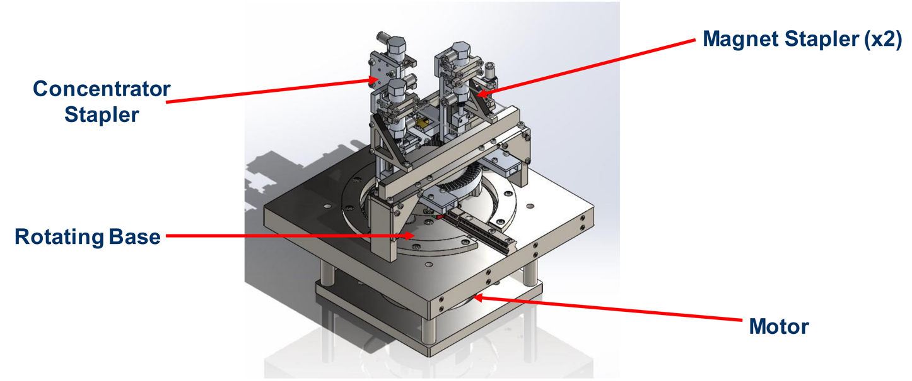Figure 6: Assembly Drawing

The Concentrator Stapler and The Magnet Stapler
At the heart of the design, the Concentrator Stapler and Magnet Stapler function as the primary assembly mechanisms. Both incorporate a two-piston operation powered by pneumatic actuators for precision and reliability. Concentrators and magnets are loaded into the respective guiding channels, and through a sequence of pneumatic piston movements, they are pushed into precise positions onto the magnetic ring. The strategic use of magnetic attraction in the Magnet Stapler further ensures a smooth transition of the magnets into the correct placement.

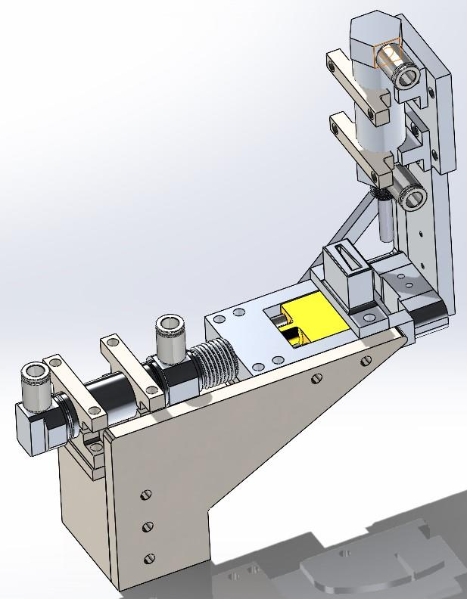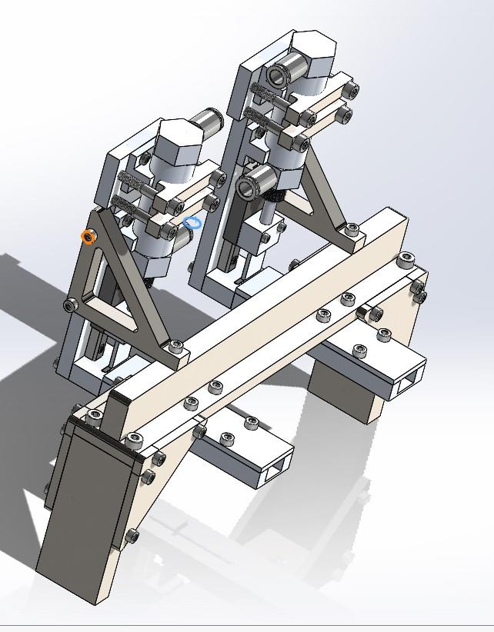
Figure 7&8: The Concentrator Stapler and The Magnet Stapler

The Rotating Base
The Rotating Base, a stable base plate with a free-spinning center attached to a shaft, offers a rotation mechanism for the magnetic ring. Equipped with a rail, it enables the sliding of the ring in and out of position between operations, allowing for a continuous, smooth assembly process.

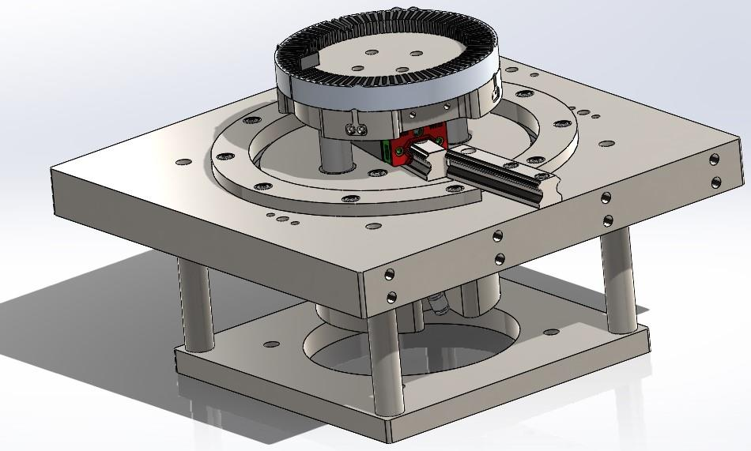
Figure 9: The Rotating Base

The Direct Drive Motor System and The Pneumatic Actuator
The Direct Drive Motor System and the Pneumatic Actuator are vital to maintaining the accuracy and efficiency of the assembly process. The Direct Drive Motor, delivering high torque at low rotational speeds, controls the rotation of the magnetic ring. The elimination of transmission means fewer chances of component failure, ensuring a smoother operation. On the other hand, the Pneumatic Actuator, which converts compressed air into mechanical motion, serves as a quick and reliable firing mechanism for both the Concentrator and Magnet Stapler, thus offering precise and consistent movement for component insertion.

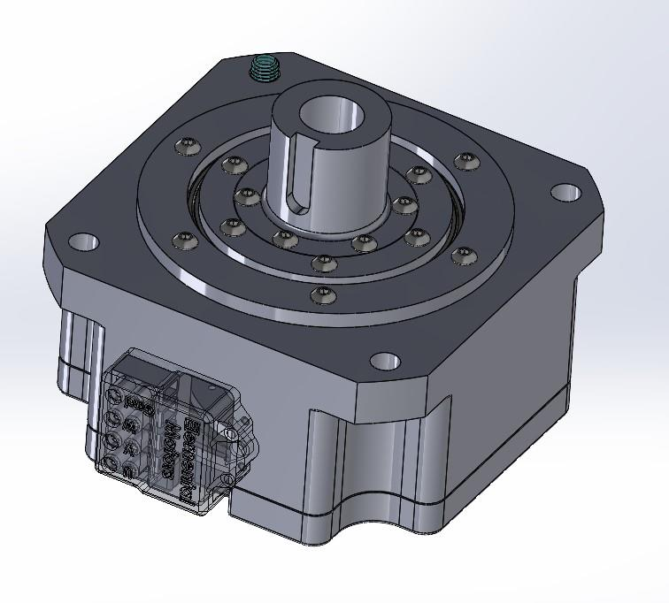
Figure 10: Motor

PLC System
Finally, our PLC system is the automation centerpiece of the entire machine. Once loaded and started, the machine can perform the entire assembly process without human interaction, embodying true automation. By controlling and coordinating all the individual components, the PLC system ensures a significant reduction in assembly time and a notable increase in production efficiency.

Together, these components form an interconnected assembly system that vastly improves efficiency, reduces costs, and accelerates the process of manufacturing magnetic rings. We have designed a machine that not only meets but exceeds customer requirements, offering a future-ready solution for automated assembly in motor production.

Design changes
Since the Preliminary Report, our project design has largely maintained its fundamental structure and overall functionality. However, adjustments have been made to specific component dimensions to better align with our customer requirements and engineering requirements. These modifications are not fundamental changes, but rather fine-tuning adjustments aimed at optimizing our design for increased efficiency, improved reliability, and reduced cost.

For instance, adjustments were made to the size of the pistons in both the Concentrator Stapler and the Magnet Stapler. By fine-tuning these dimensions, we were able to achieve more precise placement of components onto the magnetic ring, improving the efficiency of our machine. Similarly, minor modifications were made to the Rotating Base to enhance the smoothness of the rotation mechanism and to ensure more precise positioning of the magnetic ring. These seemingly subtle changes contribute significantly to improving the overall performance and reliability of our automated assembly machine.

Engineering Calculations
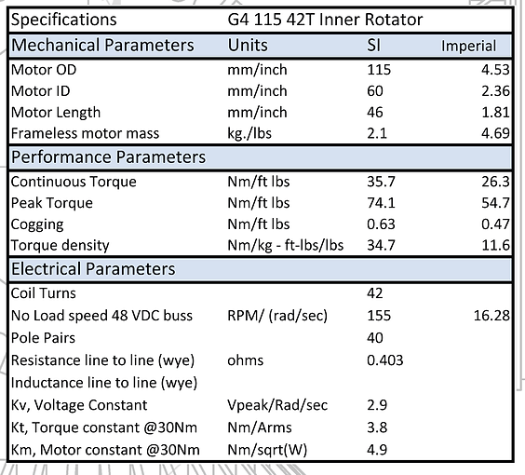
Figure 11: G4 115 Electric Motor
G4 115 Electric Motor
τ = P / ω
ω = 155 RPM = 16.28 rad/s
P = 1206W
τ = P / ω = 1206 W / 16.28 rad/s = 74.08 Nm > 50 Nm (engineering requirement)
η = (Output power / Input power) * 100%
P_in = 1340 W
P_out = 1206 W
η = (1206 W / 1340 W) * 100% = 90%

Learning and Reflection from prototype
In the process of creating the prototype, our team gained valuable insights into the practical aspects of our design, allowing us to understand and anticipate potential issues that might not have been evident in theoretical planning alone.

One of the key lessons learned was the importance of precision in component manufacturing and assembly. Minor deviations in the size or alignment of components, such as pistons in the Concentrator Stapler or the Magnet Stapler, can greatly affect the overall efficiency and accuracy of our machine. As a result of these findings, we made adjustments to our final design, ensuring stringent quality control measures in parts manufacturing and a more rigorous assembly process.

In addition, we learned more about the capabilities and limitations of our chosen materials during the prototype construction phase. This prompted us to review the materials used for certain components, particularly those subject to high wear and tear, in order to increase the durability and longevity of the final product. The implementation of these changes in our final design has significantly improved the overall reliability and cost-effectiveness of our project.

Implementation Plan

Preparation of the implementation plan
Our implementation plan is designed to translate our theoretical design into a tangible, working model that validates our approach and fulfills our customer requirements.

We plan to start the implementation process by fabricating the prototype. The key components, such as the Concentrator Stapler, Magnet Stapler, and Rotating Base, will be precisely machined according to the specifications outlined in our design. The process will involve close collaboration with experienced machinists, ensuring our design is accurately represented in the manufactured components. Additionally, stringent quality control measures will be employed during the fabrication process to ensure that each component adheres to the necessary dimensional and quality standards.

Simultaneously, we will focus on programming the control system for our design using MATLAB, which will be interfaced with a PLC system for automation. Our MATLAB code ensures the correct timing and operation of the stapling process to staple all 160 components within three minutes, as per our customer requirements.

% define total time for process, number of components, loading time and reset time
totalTime = 3*60; % time in seconds
numComponents = 160;
loadingTime = 0.5; % in seconds
resetTime = 0.3; % in seconds

% calculate time per component including loading and resetting
timePerComponent = (totalTime/numComponents) - (loadingTime + resetTime); % in seconds

% create time vector
t = 0:timePerComponent+loadingTime+resetTime:totalTime-(timePerComponent+loadingTime+resetTime);

% create output vector for stapler state (0 = not firing, 1 = firing)
staplerState = zeros(1, length(t));

% create output vector for loading state (0 = not loading, 1 = loading)
loadingState = zeros(1, length(t));

% iterate over time vector and set stapler to fire and load at appropriate times
for i = 1:length(t)
% set stapler to fire at the start of each component's time slot
if t(i) >= (i-1)*(timePerComponent+loadingTime+resetTime) && t(i) < (i-1)*(timePerComponent+loadingTime+resetTime)+timePerComponent
staplerState(i) = 1;
end
% set loading to occur immediately after stapling
if t(i) >= (i-1)*(timePerComponent+loadingTime+resetTime)+timePerComponent && t(i) < i*(timePerComponent+loadingTime+resetTime)
loadingState(i) = 1;
end
end

% output time, stapler state, and loading state vectors
[t; staplerState; loadingState]

The MATLAB code provided above demonstrates the core logic of the PLC program. It calculates the time needed for stapling each component while accounting for loading and resetting times. The result is an optimal operation sequence that ensures the efficient processing of all components within the allotted timeframe.
Upon the completion of these steps, the individual components will be assembled and integrated with the PLC system. Rigorous testing will be performed to evaluate the performance and efficiency of the prototype. Necessary adjustments will be made based on the findings from these tests, and then a final validation process will ensure that our design meets all customer and engineering requirements.

By following this implementation plan, we aim to achieve a seamless transition from design to the operation of a fully functioning prototype, ensuring that our design meets the project objectives effectively and efficiently.

Resources required to implement the plan
In the implementation of our chosen design, a variety of resources are required, including but not limited to, information, manpower, materials, and facilities.

Our design largely consists of steel and aluminum parts, requiring an estimated budget range of $1400 - $1500, which caters specifically for the structure of the stapler, excluding the drive system and the stapling system. We've also allocated a budget ranging from $200 - $350 for hardware, which includes bolts, bushings, bearings, spacers, and dowel pins. As all concepts share similar hardware, the number of components will vary between concepts. Please refer to our current Bill of Materials (BOM) for the basic functionality of the stapler.
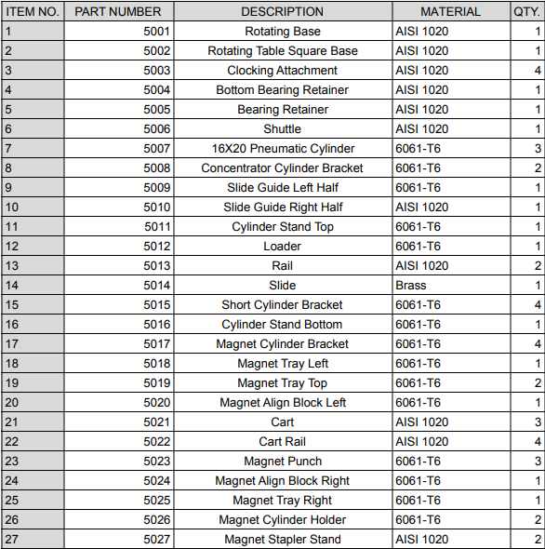
Figure 12: Bill of Materials 1
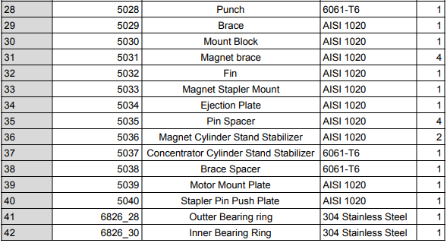
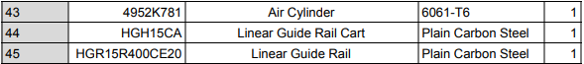
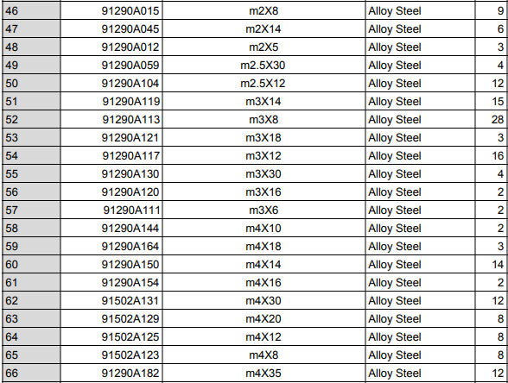
Figure 12&13: Bill of Materials 2&3

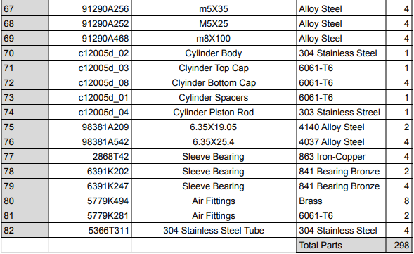
Figure 14: Bill of Materials 4

Original Manufacturing Cost: $9500
• Hardware $350: Bolts, air fittings, dowel pins, bushings, cylinders, and air lines
• Parts/ Materials $1400: Steel (AISI 1020), aluminum (6061-T6), and brass
• Machining $7,000: Improving CAD designs and drawing files for machinists
• Prototyping $200: 3D printing, machining, hardware (reusable)

Amount Saved for Final Design:
• Hardware: $50
• Materials: $100
• Machining: $200
• Prototyping: $200

Total Saved: $550
Manufacturing Cost Decreases:
• Switching from 304 SS to 6061-T6
• Getting reusable hardware
• Using cheaper 3D printing material
• Buying hardware in bulk

Use of Saved Budget:
• Component failure: Replace broken parts if needed
• Additional parts: Adding additional features to the stapler
• Needed hardware: Extra hardware for fixes and changes

The manufacturing process for all components will be carried out within Elemental Motors Company's workshop, ensuring quality control and consistency across all components of the product.

By comparing the implementation costs and our budget, we are confident in our financial feasibility and in our ability to carry out the project successfully within the allocated budget.

Second Semester Schedule
The Gantt chart below shows our second semester time schedule with some of the important tasks planned to be completed within each time zone.

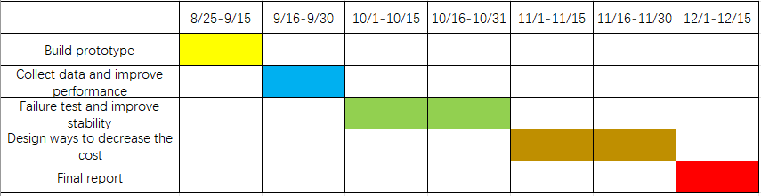
Figure 15: Second Semester Schedule
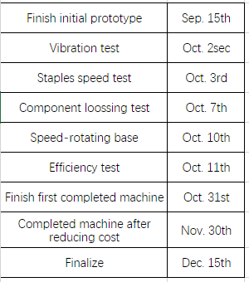
Figure 16: Important Timing

Conclusion
After teaming with Elemental Motors, the team has accomplished several key components of making this stapler a reality and decreasing Elemental Motors’ manufacturing time. Having weekly meetings with the client David Calley we have been able to stay on track and address any concerns while achieving all the needs that Elemental has for the project. The team has provided a fully designed CAD assembly with all clearances and tolerances present. Along with the CAD model most of the parts have been machined and assembled, all of which fall within the customer requirements. Moving forward with this stapler the team plans to have it fully built and tested by the middle of next semester, where we can then check for accuracy. Having this stapler built and tested will allow for areas of improvement to make the machine as effective as possible.

Appendices

Appendix A: FMEA
Item / Function | Potential Failure Mode(s) | Potential Effect(s)  of Failure | Severity | Potential Cause(s)/ Mechanism(s) of Failure | Probability | Current Design Controls | Detectability | Risk Priority Number
Rotating Base | Component Misalignment | Failure to function, damage to components | 9 | Manufacturing errors or impoper tolerancing | 7 | Determine acceptable tolerances and use CNC machine for precise machining | 3 | 189
Rotating Base | Accumulation of magnetic dust | Magnet ring assembly unable to be used in end product, device malfunction | 6 | Chipping of magnets or concentrators due to the impact of the punching piece | 5 | Ensure proper alignment and test what conditions generate magnetic dust | 6 | 180
Rotating Base | Excess Vibration | Misalignment of components, loosening of screws and other components | 6 | Vibration gradually loosening nuts, bolts, etc. | 8 | Testing to determine the vibration from the pneumatic piston and motor | 3 | 144
Rotating Base | Accumulation of debris on rotation mechanism | System fails to rotate or rotates less than expected | 6 | Byproducts of nearby manufacturing settling on mechanism | 7 | Development of routine maintenance | 3 | 126
Concentrator Stapler | Guide channel wearing down | Concentrator misalignment | 7 | Friction between concentrators and channel | 5 | Replacement channels available on hand | 3 | 105
Motor | Mistimed activation | Misalignment, damage to components | 9 | Programming failure, damage/wear to rotation or electrical elements | 2 | Extensive testing and routine maintenance cycle | 5 | 90
Concentrator Stapler | Excessive vibration | Loosening of hardware, misalignment of arm | 7 | Rotation vibration from motor into arm | 6 | Development of routine maintenance cycle | 2 | 84
Concentrator Stapler | Excessive friction on slide rails | No concentrator punched into place, damage to piston, arm, or concentrator | 6 | Dust or debris on railing, lack of lubrication | 6 | Development of routine maintenance cycle | 2 | 72
Rotating Base | Chipping or cracking | Misalignment of stapler punching component | 7 | Excessive air pressure or punching component striking at incorrect location | 3 | Don't exceed maximum air pressure and ensure proper alignment | 3 | 63
Magnetic Stapler | Buildup ofdebris and dust in channel | Failure of magnets to move into place | 3 | Friction between magnets and guiding channel, debris from manufacturing in nearby areas | 10 | Development of routine maintenance cycle | 2 | 60
Motor | Excessive vibration | Loosening of hardware, Disconnection from system | 5 | Vibration of spinning parts | 6 | Development of routine maintenance cycle | 2 | 60
Concentrator Stapler | Misalignment of arm | Failure to function, damage to components | 9 | Damage from users | 3 | No current control | 2 | 54
Magnetic Stapler | Misalignment of arm | Failure to function, damage to components | 9 | Damage from users | 3 | No current control | 2 | 54
Motor | Miscalibration over time | Damage to device and components | 3 | Gradual reduction in precision of direct drive and/or control system | 6 | Determine motor calibration and maintenance procedure and schedule | 3 | 54
Rotating Base | Wear on shaft coupler | Slipping of shaft | 5 | Fatigue in pins holding coupler in place | 5 | Development of routine maintenance | 2 | 50
Motor | Wear in shaft coupler connections | Failure of system to rotate | 5 | Fatigue in pins holding coupler in place | 5 | Development of routine maintenance | 2 | 50
Concentrator Stapler | Excessive friction on piston | Reduction of punching force, failure of punching component | 4 | Dust or debris buildup in moving parts | 3 | Development of routine maintenance cycle | 4 | 48
Concentrator Stapler | Excessive wear on punching mechanism | Concentrators not fully pushed into magnet ring | 4 | Fatigue on end of punching mechanism | 2 | Development of routine maintenance cycle | 6 | 48
Magnetic Stapler | Excessive friction on piston | Reduction of punching force, failure of punching component | 4 | Dust or debris buildup in moving parts | 3 | Development of routine maintenance cycle | 4 | 48
Magnetic Stapler | Wear on punching mechanism | Magnets not fully pushed into magnet ring | 4 | Fatigue on end of punching mechanism | 2 | Development of routine maintenance cycle | 6 | 48
Concentrator Stapler | Bending of arm | Misalignment of concentrators | 5 | Fatigue from piston force over time, damage from users | 3 | Development of routine maintenance cycle | 3 | 45
Magnetic Stapler | Bending of arm over time | Misalignment of concentrators | 5 | Fatigue from piston force over time, damage from users | 3 | Development of routine maintenance cycle | 3 | 45
Magnetic Stapler | Excessive vibration | Loosening of hardware, misalignment of arm | 7 | Rotation vibration from motor into arm | 3 | Development of routine maintenance cycle | 2 | 42
Motor | Buildup of debris in shaft | Failure to properly spin | 5 | Nearby manufacturing processes | 4 | Development of routine maintenance cycle | 2 | 40
Motor | Failure of encoder connection | Lack of function of system | 3 | Wear in electrical components, environmental debris | 4 | Development of routine maintenance cycle | 3 | 36
Motor | Overheating | Breakdown of motor, lowered lifecycle | 3 | Excessive heat in operating environment | 3 | Cooling system to be placed in area | 4 | 36
Rotating Base | Vibration at resonant frequencies | System failing or collapsing | 10 | Creating a design without verifying that the device will not be exposed to its resonant frequencies | 3 | Vibration simulation to determine resonant frequencies | 1 | 30
Motor | Power overload/surge | Failure of motor function | 9 | Power outage, environmental factors | 3 | UPS at power connection | 1 | 27
Concentrator Stapler | Inadequate force to fit concentrators | Concentrators not fully pushed into magnet ring | 4 | Inadequate lubrication | 3 | Test devices function regularly and lubricate as needed | 2 | 24
Concentrator Stapler | Deformation of punching component | Concentrators not fully pushed into magnet ring | 3 | Excessive air pressure or number of stress cycles | 2 | Determine acceptable range of air pressures that do not damage the components | 4 | 24
Magnetic Stapler | Wear on guide channel | Misalignment of magnets | 6 | Friction between magnets and guiding channel | 2 | Development of routine maintenance cycle | 2 | 24
Magnetic Stapler | Inadequate Force to fit magnets | Magnets not fully pushed into magnet ring | 4 | Inadequate lubrication | 3 | Test devices function regularly and lubricate as needed | 2 | 24
Magnetic Stapler | Deformation of punching component | Magnets not fully pushed into magnet ring | 3 | Excessive air pressure or number of stress cycles | 2 | Determine acceptable range of air pressures that do not damage the components | 4 | 24
Rotating Base | Pull from magnetic components on rotating elements | Lack of rotation into proper place | 7 | Mistake in material selection | 1 | Utilize non-magnetic material outside of magnet arm where desired | 3 | 21
Rotating Base | Bending in rotating shaft | Misalignment, Unanticipated stress on rotational plate holding | 5 | User damage | 2 | No current control | 2 | 20
Concentrator Stapler | Pneumatic leak | Inability of piston to drive parts | 2 | Damage to hoses or gaskets within pistons | 6 | Development of routine maintenance cycle | 1 | 12
Magnetic Stapler | Pneumatic leak | Inability of piston to drive parts | 2 | Damage to hoses or gaskets within pistons | 6 | Development of routine maintenance cycle | 1 | 12
Rotating Base | Friction between stable plate and rotating element | Resistance to rotation | 6 | Improperly machined parts | 2 | Ensure parts machined within tolerance | 1 | 12
Motor | Corrosion | Breakdown of motor, lowered lifecycle | 3 | Excessive moisture and humidity in operating environment | 2 | Keep away from entrances and exits to shop, avoid machines that utilize moisture | 2 | 12
Motor | Physical damage | Breakdown of motor, lowered lifecycle | 3 | user damage | 1 | Motor kept shielded and not accessible to accidental strikes | 2 | 6

Appendix B: Bill of Materials

